Media player:
This module plays the songs in the background.

This figure shows the login page for a registered user. The user can input the credentials and can log into the app to use the modules.

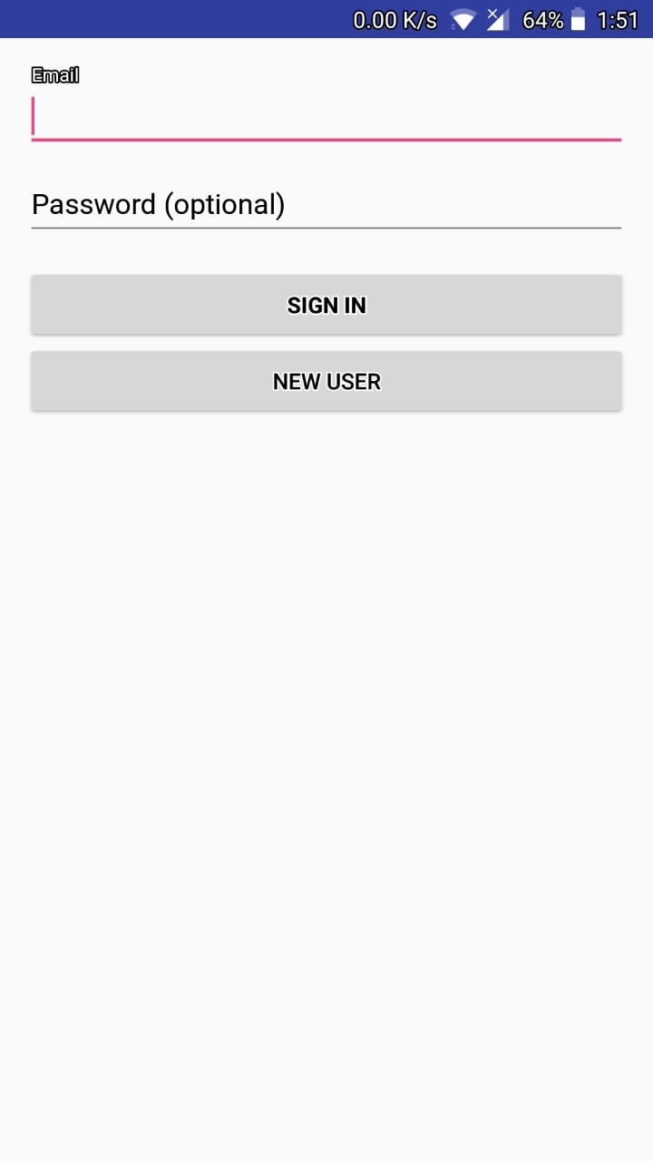

Fig 13 Login Page of the app

The figure shows the Registration page for a new user. The user needs to provide the details and they will be fed into the database

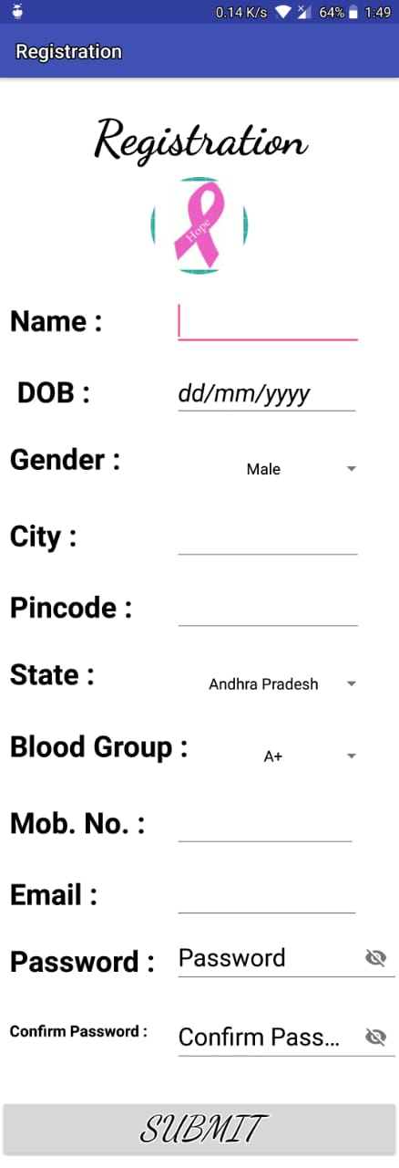

Fig 14 Registration Page of the app

The figure shows the main page of the application. It shows the modules of the app. The voice assistant communicates the module name to the user via speech.

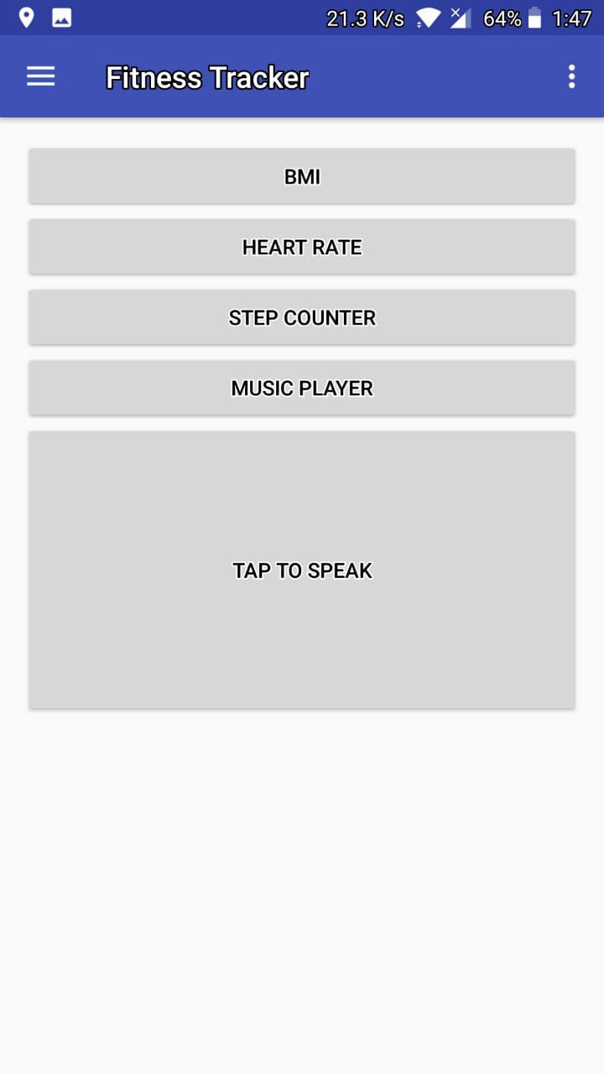

Fig 15 Main page of the app

This figure shows the Media Player. The song will be chosen by the user and the same will be played in the background.



Fig 16 Media Player

The figure asks the user for the input to take the user details to calculate BMI and calories taken by the user

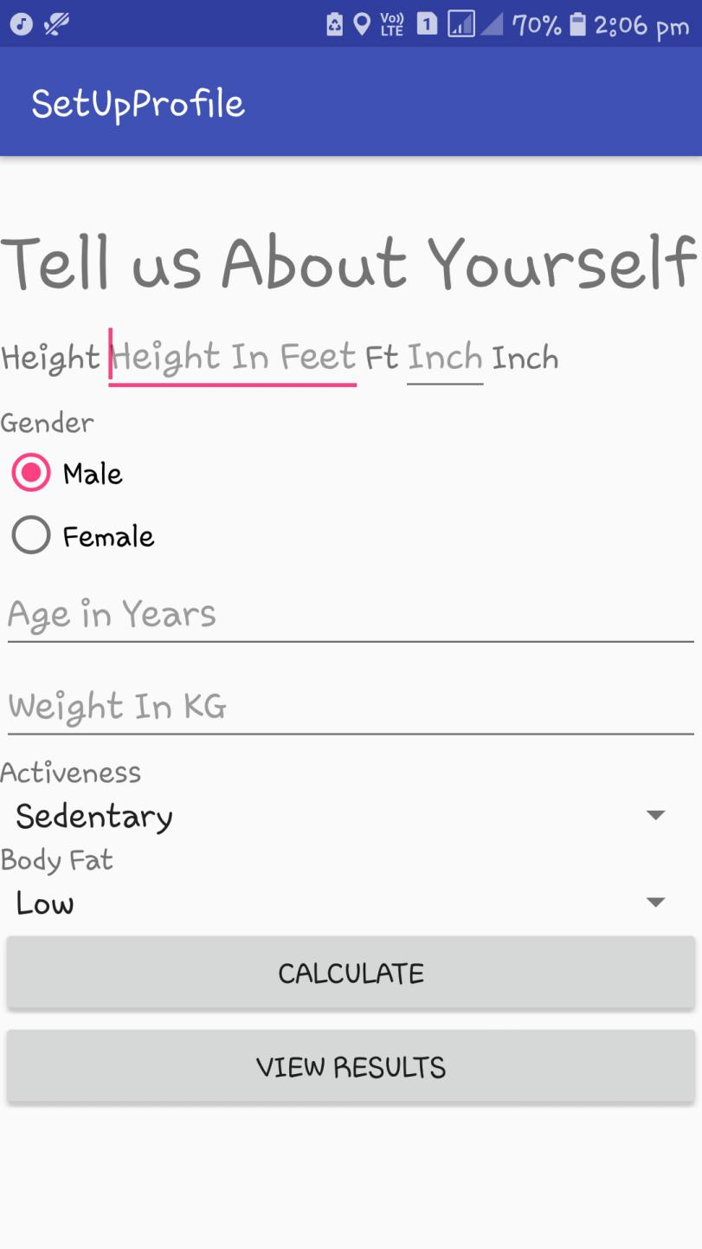
Fig 17 Registation Page for BMI/Calorimeter

The fiigue shows the result of the BMI calculations and the calories needed for the user.

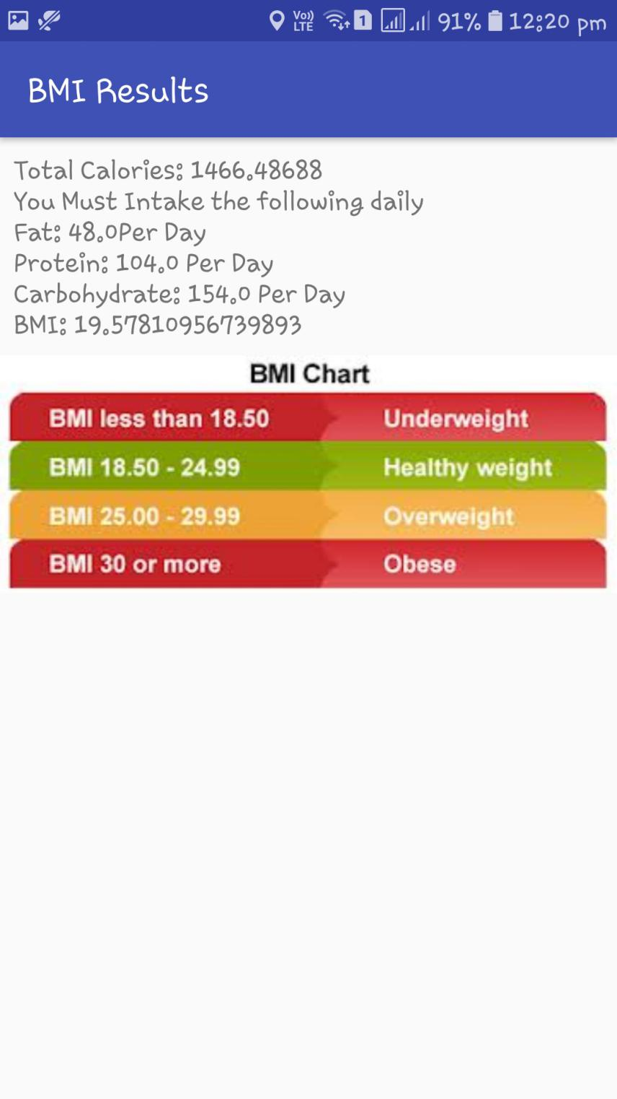

Fig 18 Calorimeter Results Page of the app

The figure shows the number of steps of user.



Fig 19 Pedometer Results

The figure shows the heart beat sensor in the app. It communicates the result to the
user via voice assistant

. 

Fig 20 Heart rate sensor/input page

The figure shows the heart beat of the user and the same is communicated to the user via voice assistant.

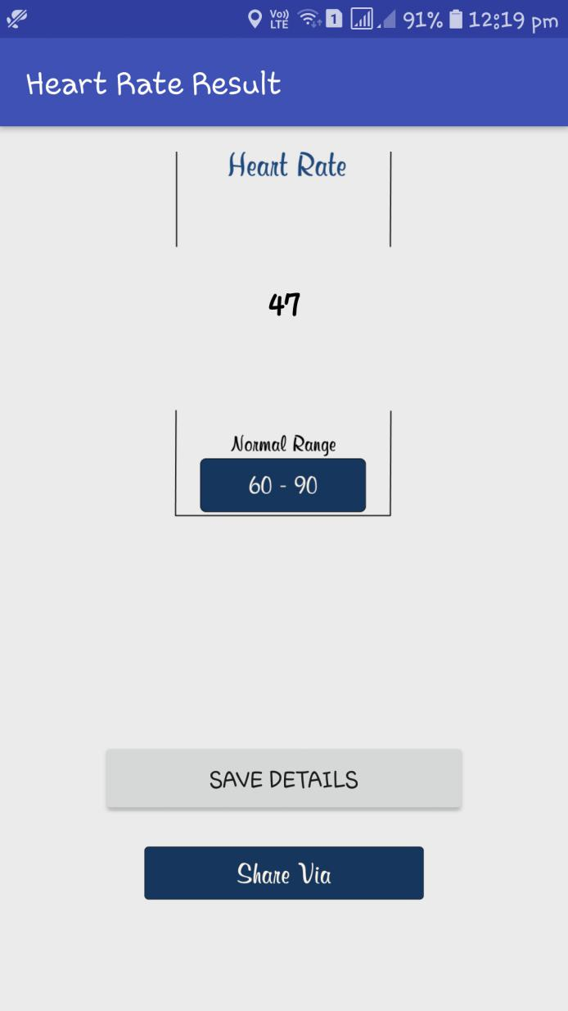

Fig 21 Heart rate result page

